WORKSHEET

TOPIC: EQUIVALENT RESISTANCE

1.
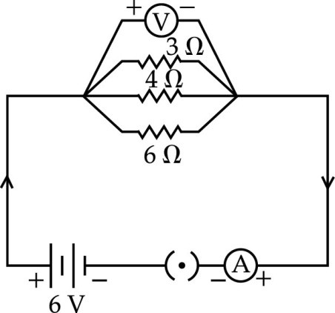

State ohm‟s law. Represent it graphically. In the given circuit diagram calculate
(i) the total effective resistance of the circuit.
(ii) the current through each resistor.
2.
Calculate
- The value of current through each resistor
- Total current drawn from battery
- Total effective resistance
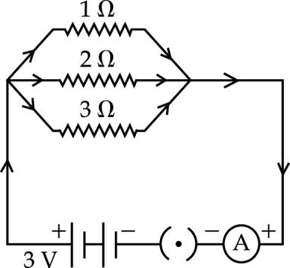

3. Find the total resistance between the points A and B in the circuit
diagram shown.
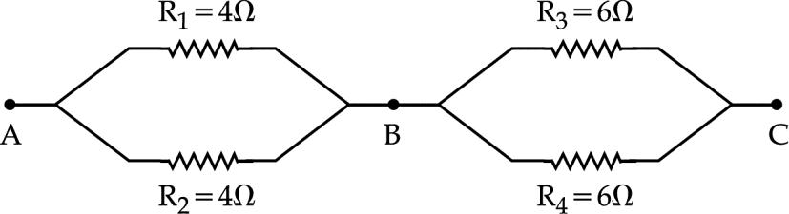

4. A current of 0.6 A shows in the circuit when the key K2 is closed. Find the resistance of the lamp L. Now if the key K2 is also closed, what change in current flowing through the 5 Ω conductor and potential difference across the lamp will take place. State reason for your answer.
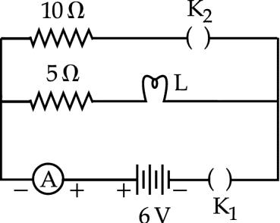

5. State the type of combination of the two resistors in the circuit. How much current is flowing through 10 $Ω$ and 15 $Ω$ resistors ? What is the ammeter reading ?

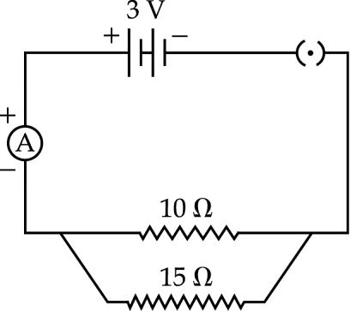
6. Calculate
i. Total Effective Resistance
ii. Value of current through each resistor
iii. Total current drawn from the battery
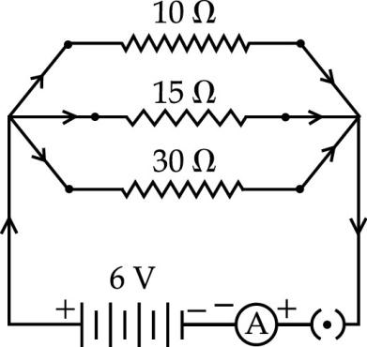

7. Find the value of current I in the circuit given below :
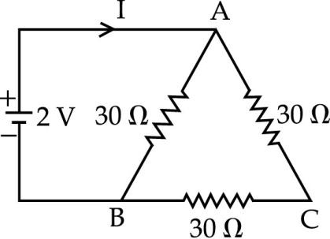
8. Find the current flowing through the following electric circuit.
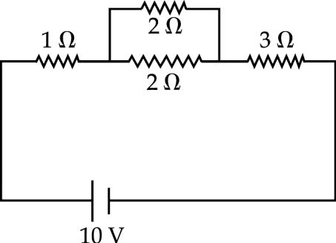
9. Calculate-
(a) the total resistance of the circuit,
(b) the current through the circuit, and
(c) the potential differences across R1 and R2
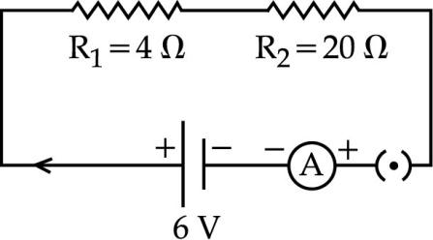

10. Find the equivalent resistance of the following circuit-
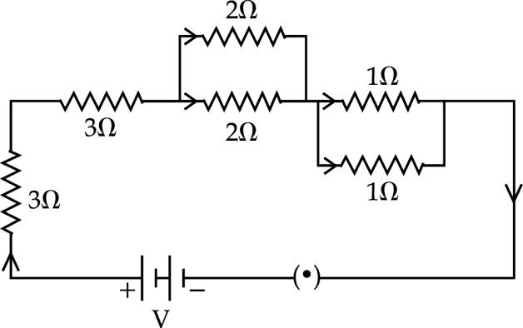
11. For the circuit given below, calculate –
(i) current through each resistor.
(ii) total current in the circuit.
(iii) total resistance in the circuit.
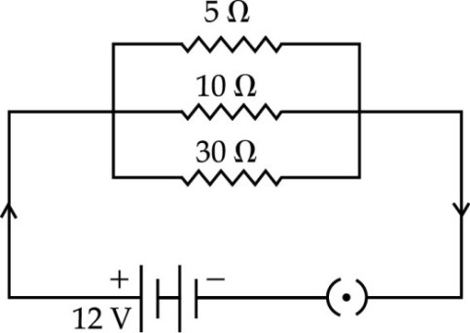

12. The following combination has an effective resistance of 8. Calculate the value of ‘R’.
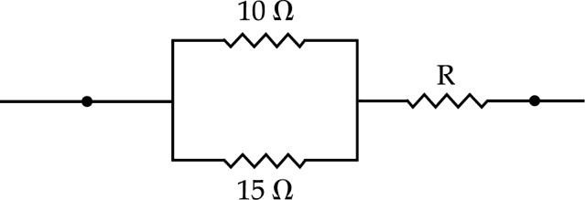

13. Find the equivalent resistance across the two ends A and B of this circuit.

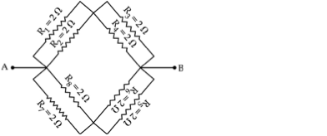

14. In the above circuit diagram, calculate :
(a) the value of current through each resistor
(b) the total current in the circuit
(c) the total effective resistance of the circuit.
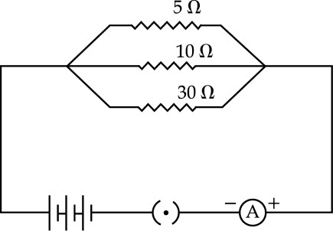
15. Find out the following in the electric circuit given in the figure.

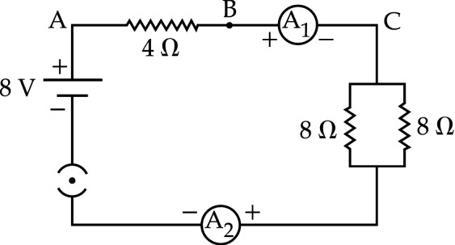
(a) Effective resistance of two 8  resistors in the combination
(b) Current flowing through 4  resistor
(c) Potential difference across 4  resistor
(d) Power dissipated in 4  resistor
(e) Difference in readings of ammeter A1 and A2 if any
16. Find out the reading of ammeter and voltmeter in the circuit given below :


